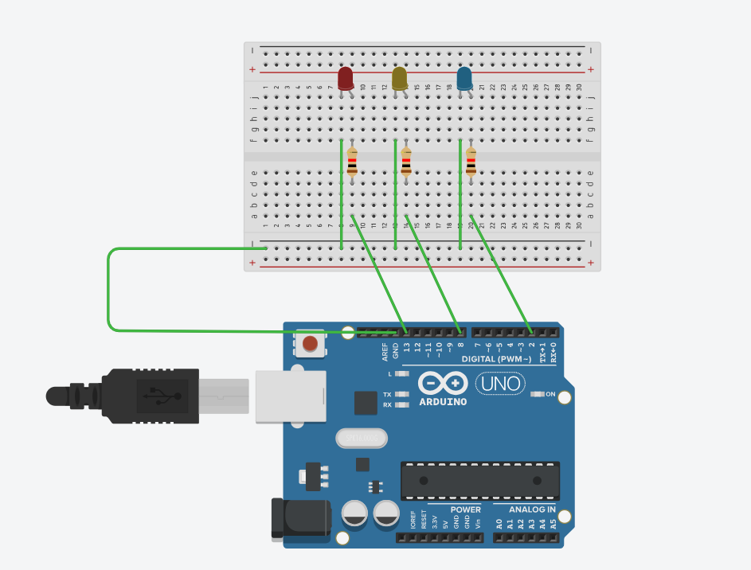

CODE :
// C++ code
//
int 9=13;
int 14=8;
int 20=2;
void setup()
{
pinMode(11, OUTPUT);
pinMode(12, OUTPUT);
pinMode(13, OUTPUT);
}

void loop()
{
digitalWrite(11, HIGH);
delay(1000); // Wait for 1000 millisecond(s)
digitalWrite(11, LOW);
delay(1000); // Wait for 1000 millisecond(s)

digitalWrite(12, HIGH);
delay(1000); // Wait for 1000 millisecond(s)
digitalWrite(12, LOW);
delay(1000); // Wait for 1000 millisecond(s)

digitalWrite(13, HIGH);
delay(1000); // Wait for 1000 millisecond(s)
digitalWrite(13, LOW);
delay(1000); // Wait for 1000 millisecond(s)
}

